Chapter 6, Solution 60

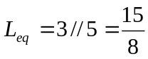
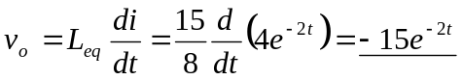

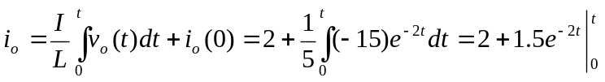

i_{o} = (0.5 + 1.5e^{–2t}) A

